

LAB PROJECT REPORT

for

ECE2244: VLSI Design Lab

“VENDING MACHINE USING VERILOG”

Submitted by

Vatsal Jindal
Reg. No.:230959166
Batch: A3

Akash Paul
Reg. No. 230959162
Batch:A3

DEPT.OF ELECTRONICS AND COMMUNICATION (ECE) MANIPAL INSTITUTE OF TECHNOLOGY, MANIPAL-576104

25 March , 2025

Index

- Objective
- Chapter 1: Introduction
- Chapter 2: Project Theory Explanation
- Chapter 3: Verilog Code and TestBench
- Chapter 4: Results (Waveform/Synthesized Circuit/Layout)
- Conclusion
- References

OBJECTIVES
- To design and implement a vending machine using Verilog that dispenses items and provides change based on the inserted amount.
- To apply Finite State Machine (FSM) concepts for efficient state transitions and logical control of the vending machine.
- To simulate and verify the functionality of the vending machine using test benches and waveform analysis.
- To develop a practical approach for handling user inputs, item selection, and change return mechanisms.
- To demonstrate the ability to model real-world vending machine behavior using HDL (Hardware Description Language).

INTRODUCTION
A vending machine is an automated device that allows users to purchase products by inserting money and selecting an item. It operates on a well-defined state transition mechanism to ensure correct item dispensing and change return. In this project, a Verilog-based vending machine is designed and implemented using the Finite State Machine (FSM) approach.
The vending machine accepts predefined denominations, processes user selections, and dispenses items accordingly. If the inserted amount exceeds the item cost, the machine calculates and returns the change. The FSM governs the states, including idle, money insertion, selection processing, item dispensing, and change return.
This project provides hands-on experience in digital design using Verilog, covering concepts such as state machines, sequential logic, and testbench creation for verification. The design is simulated to verify its functionality, and the output waveforms demonstrate correct operation under different test scenarios.

PROJ.ECT THEORY

Overall Working of the Vending machine:
The vending machine holds only one product, and the cost of the product is 15 Rs. The accepted input currencies in the vending machine are 5Rs and 10Rs.
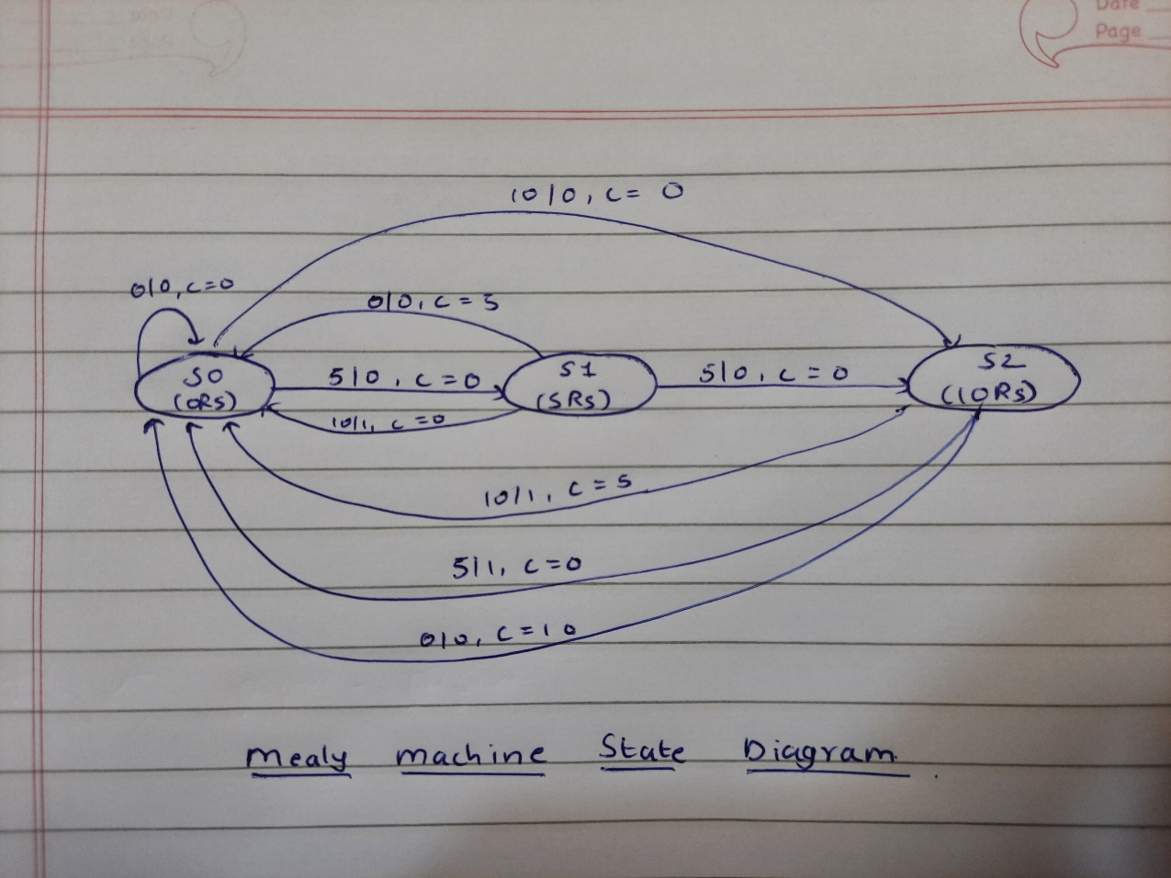
A Mealy machine is a type of Finite State Machine (FSM) where the outputs depend on both the current state and the inputs. This contrasts with a Moore machine, where the output depends only on the current state.
The vending machine has 3 states :
- S0 : When the machine has 0 Rs
- S1: When the machine has 5 Rs
- S2: When the machine has 10Rs
There is no further state , because if the machine has 15 Rs , that means that the transaction is complete and it will revert back to the original state (S0).
Working of the FSM:
- If the vending machine has 0 Rs, adding 0 Rs will make no difference and there will be no change returned. Hence the machine stays at S0.
- If 5 Rs is added in the machine, then it will move to S1, however output will still be 0, and the change returned will also be 0. If nothing is added in S1, then the machine will give back the change of 5 Rs.

- Adding 10 Rs to the machine will take it to S2. Adding 5 Rs when in S1 will also result in the machine going to S2. The transaction is not complete, and product is not returned. If nothing is further added in S2, the machine will give back a change of 10 Rs.

- In S1, if 10 Rs is added , the transaction is complete and output will be 1, but no change will be given.

- In S2, if 5 Rs is added, the transaction is complete and output will be 1, but no change will be given. If 10 Rs is added in S2, there will be an overflow condition, the output will be 1, and a change of 5 Rs will be given.

VERILOG CODE
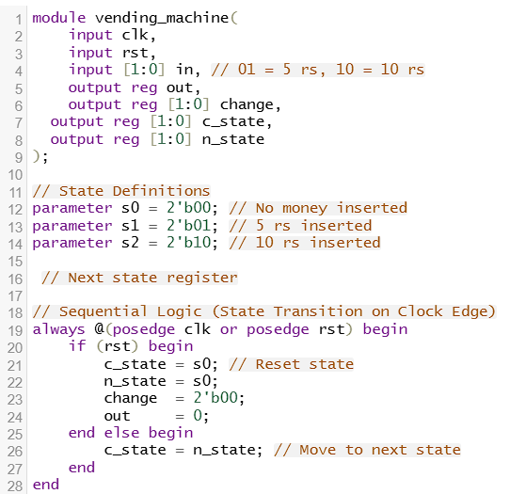
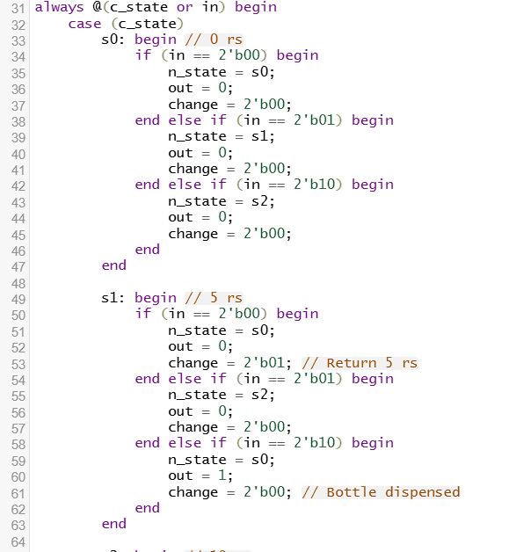
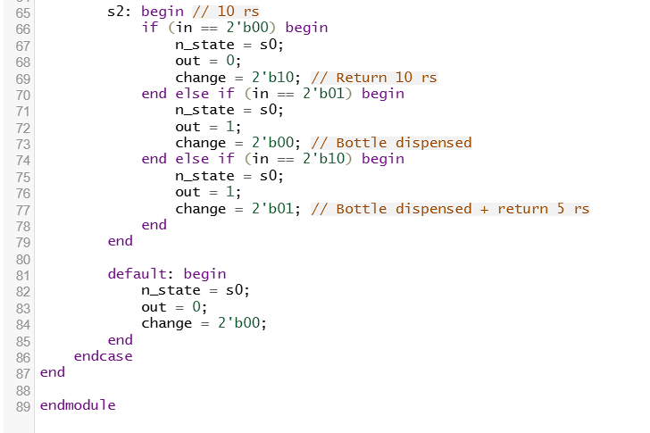

TESTBENCH
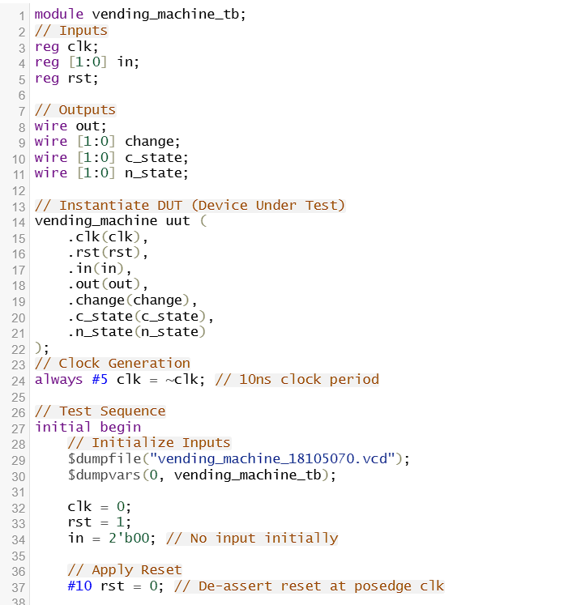
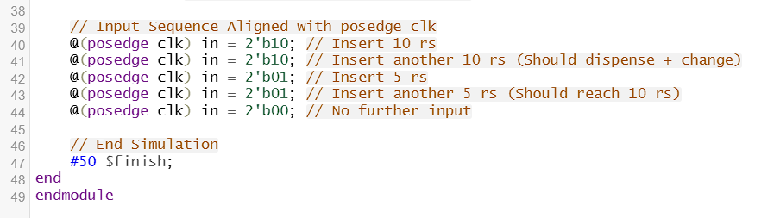

- SDC File:
create_clock -name clk -period 2 -waveform {0 1} [get_ports "clk"]
set_input_delay -max 0.3 -clock clk [all_inputs]
set_output_delay -max 0.3 -clock clk [all_outputs]
set_input_transition 0.2 [all_inputs]
set_max_capacitance 30 [get_ports]
set_clock_transition -rise 0.1 [get_clocks "clk"]
set_clock_transition -fall 0.1 [get_clocks "clk"]
set clock uncertainty 0.01 [get_ports "clk"]

- TCL File:
read_libs /home/install/FOUNDRY/digital/90nm/dig/lib/slow.lib
read_hdl vending.v
elaborate
read_sdc vending_machine.sdc
set_db syn_generic_effort medium
set_db syn_map_effort medium
set_db syn_opt_effort medium
syn_generic
syn_map
syn_opt
report_timing > vm_timing.rep
report_area > vm_area.rep
report_power > vm_power.rep
write_hdl > vm_netlist.v
write_sdc > vm.sdc
gui_show

RESULTS:
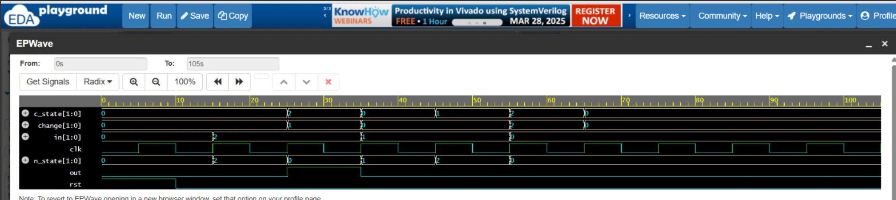
- Adding 5 Rs three times consecutively
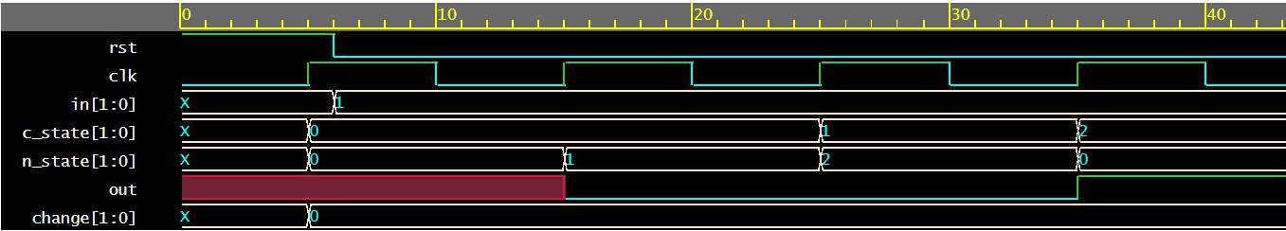
- Adding 5 Rs and then 10 Rs
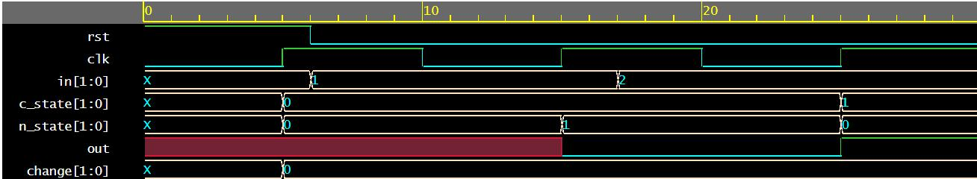
- Adding 10 Rs two times
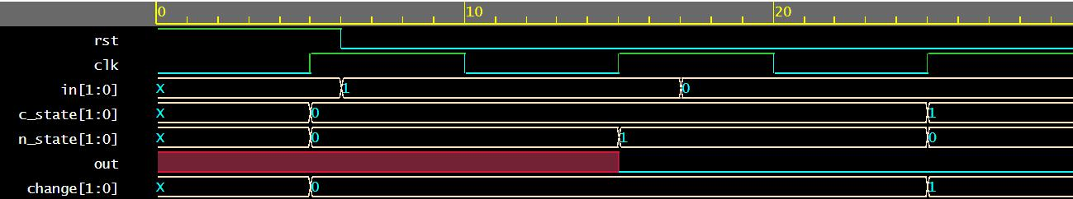

- Adding 5 Rs and then nothing
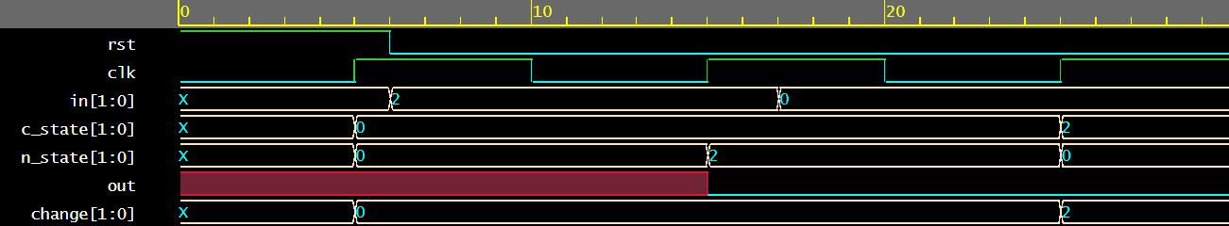

- Adding 10 Rs and then nothing
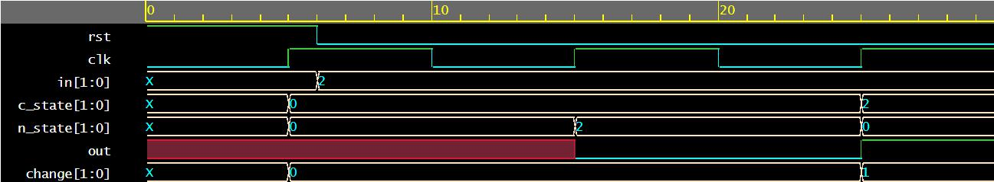

- Power report:
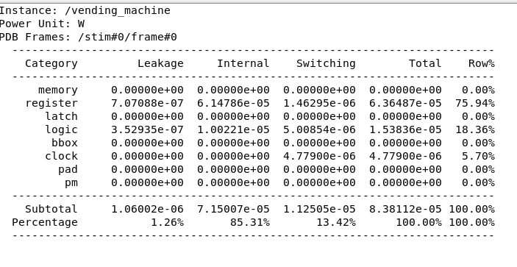

- Area Report:
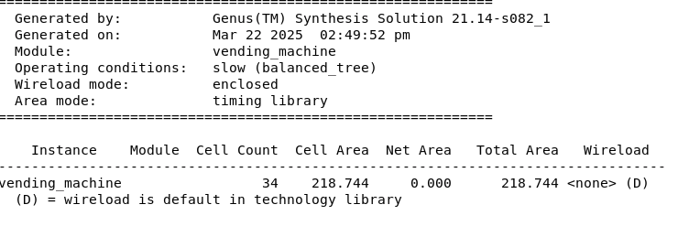

- Generated SDC :
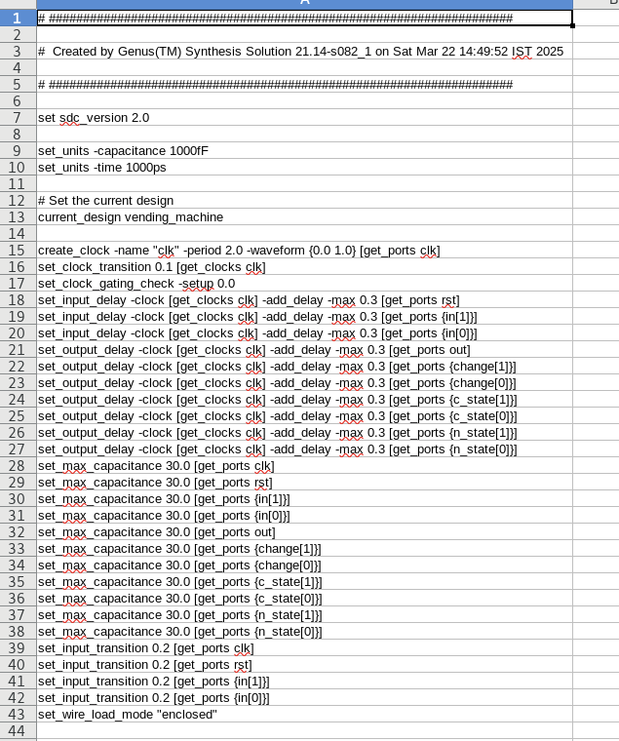

- Conclusion:
- This project successfully designed and implemented a vending machine using Verilog, employing Finite State Machine (FSM) concepts to manage state transitions and logical control. The vending machine accepts predefined denominations of 5 Rs and 10 Rs, processes user selections, and dispenses items accordingly. It calculates and returns change if the inserted amount exceeds the item cost. The FSM ensures efficient state transitions through three main states: S0 (0 Rs), S1 (5 Rs), and S2 (10 Rs).
- The project achieved its objectives by simulating and verifying the vending machine's functionality using test benches and waveform analysis. It demonstrated a practical approach to handling user inputs, item selection, and change return mechanisms. The design effectively models real-world vending machine behavior using Hardware Description Language (HDL), providing hands-on experience in digital design concepts such as state machines and sequential logic.
- The successful simulation and verification of the vending machine under various test scenarios validate the design's correctness and functionality. This project showcases the application of theoretical concepts in digital design to real-world problems, enhancing understanding and skills in VLSI design and Verilog programming.

- References:
- https://en.wikipedia.org
- https://youtube.com/
- https://www.edaplayground.com/

